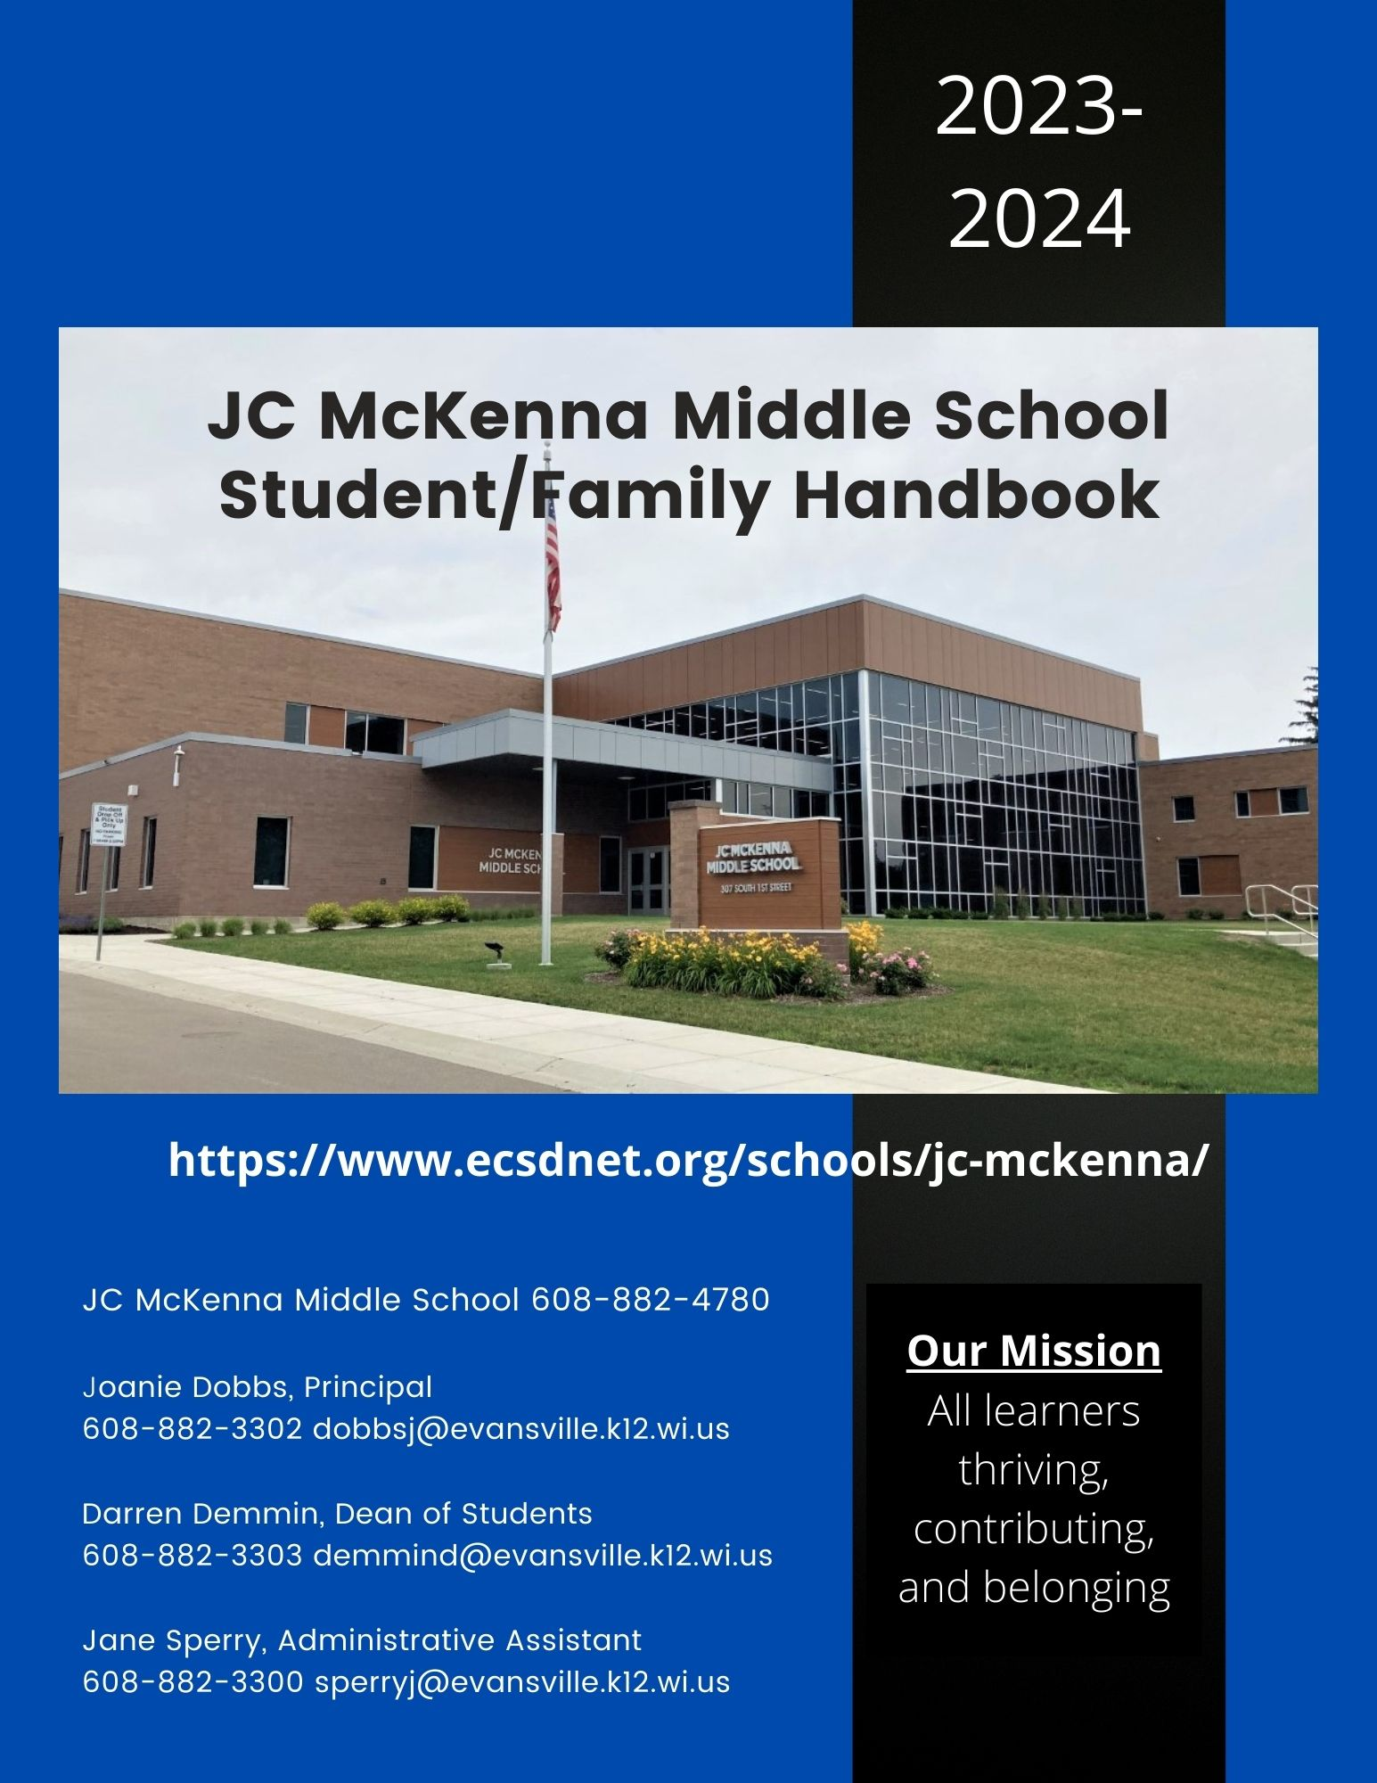

**Principal’s Welcome**

Welcome to JC McKenna Middle School, JCM. If you are new to Evansville, I hope that you have already received a warm welcome to our community. If you are returning to JCM this fall, I can’t wait to see you at school.

Our JCM community is committed to all of our students and believe that every student deserves a quality education to help each child succeed. We as staff at JCM are committed to working with you and your family to ensure that all students can learn and grow in a safe and supportive environment.

As a student at JC McKenna, you will experience many changes during your middle school years. There will be new and old friends, a variety of teachers, different coursework along with more opportunities to be involved at school. I encourage you to allow yourself to try new things and join a club, group or athletic team. If there isn’t something that grabs your interest, let us know. Middle school years go by quickly and I want you to make the most of every opportunity.

This handbook is intended to share information that will help staff, students and families to work together to support all of our students. If you have any questions, please do not hesitate to contact me. We at JCM look forward to working with and getting to know each of you this school year!

Joanie Dobbs, JC McKenna Middle School Principal

608.882.3302

[dobbsj@evansville.k12.wi.us](mailto:dobbsj@evansville.k12.wi.us)

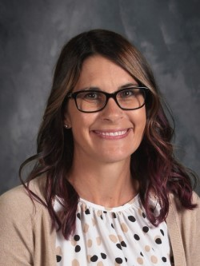



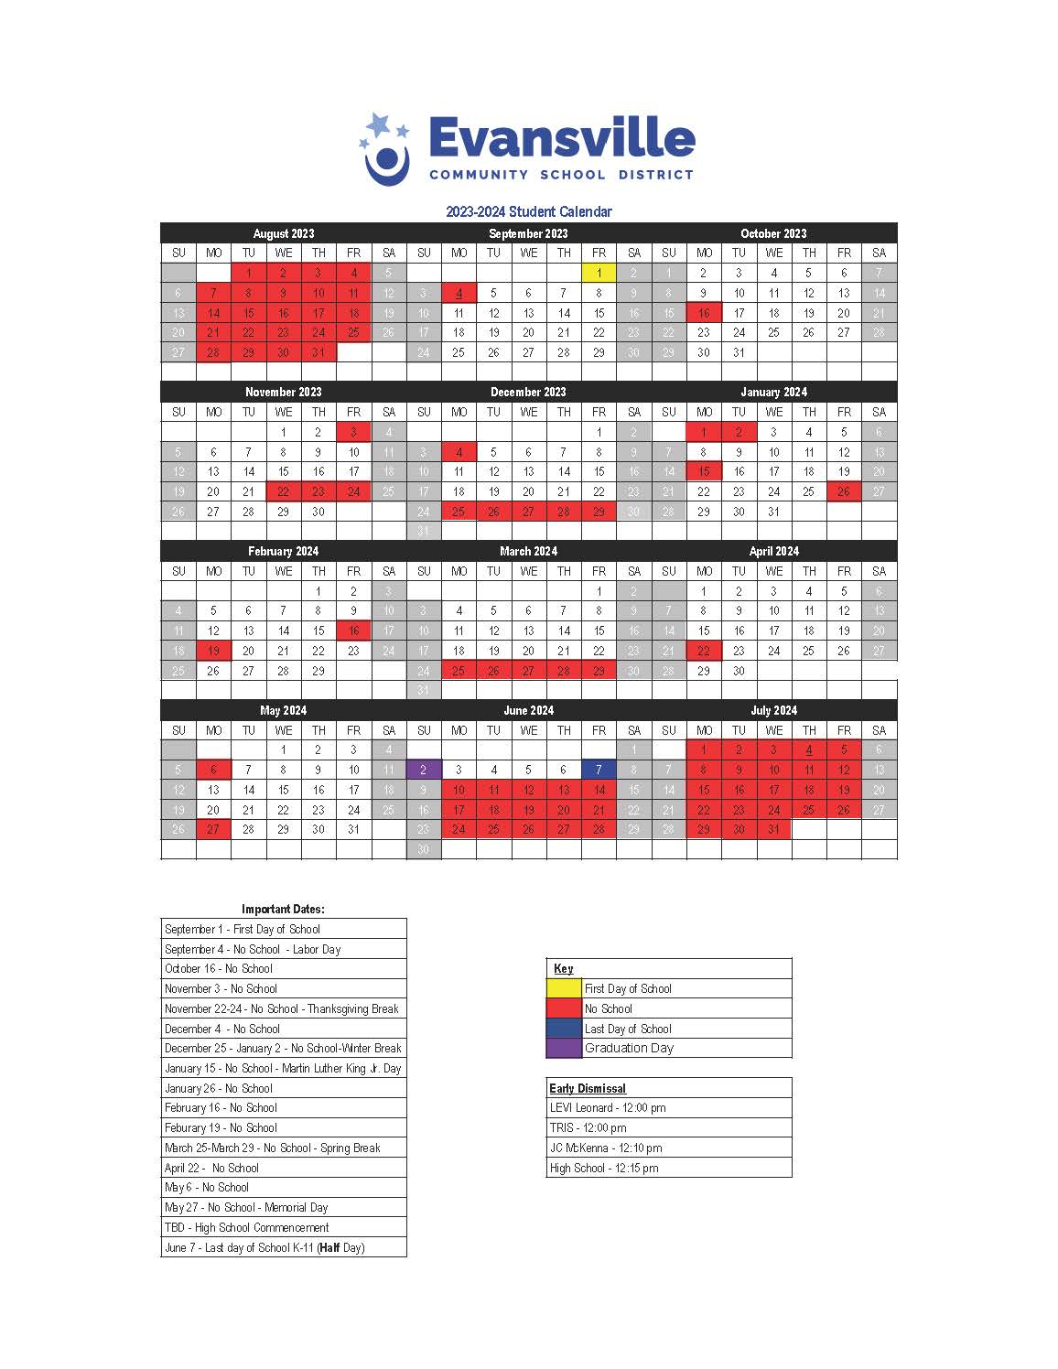



**Daily Procedures for Families and Students**

**Attendance**

* Parents/guardians should notify the school office prior to the start of school the morning of an unexpected absence.
* Planned/scheduled absences should be communicated to the school office prior to the absence.
* See School Attendance Policy 430 for additional information.

**School Day**

The school day begins at 7:50 and ends at 3:10. Students arriving after 7:50 am will check in at the school office. If a student repeatedly arrives late to school, the Dean of Students and /or Principal will develop a support plan with the student and family. Students enter the building at 7:45 am.

**Tardy to School**

Students arriving after 7:50 will be marked tardy and need to check in at the school office. After repeated tardiness to school, the student will meet with either the Dean of Students or Principal to discuss a plan to get to school on time.

**Appointments During the School Day**

Students who need to leave during the school day must obtain a pass from the office. A pass is issued to students after parents/guardians have contacted the school to inform of the absence.

**Drop off & Pick up**

* Please drop off and pick up students using the drop off & pick up lane located off of First Street. Vehicles should pull all the way through the drop off lane before students exit the vehicle so that traffic on First Street isn’t interrupted. We ask that Liberty Street and Second Street not be used as a drop off or a pick-up location as it interferes with the bus traffic.
* Bus drop off/pick up: The bus lane enters the school property from Second Street and exits on Liberty Street. Students riding the bus to school will walk through the building and go to the playground/blacktop area until the start of the school day.

**Visitor Access**

During the school day, visitors must enter through the main office door. All visitors will provide photo identification to enter the building past the main office. A visitor badge will be worn while in the building. Upon leaving, visitors will check out at the office and leave the visitor pass with the office personnel. Students from other school districts are not permitted without prior approval. See Policy 860 for additional information.

**Students’ Day**

**Announcements**

Our student council representatives read announcements daily. In addition, televisions throughout the building rotate through informational slides. JC McKenna staff will communicate with families for bigger events such as field trips and concerts however, smaller events such as dress up days and after school dances throughout the year will be communicated to the students during the school day. We view this as an opportunity for the students to begin to gain skills in independence.

**Backpacks**

Backpacks and other bags may be brought to school but should be kept in students’ lockers during the school day.

**Breakfast & Lunch (Food Service)**

* Breakfast is available for all students after the first block of classes.
* Lunch is served in the cafeteria by grade level at the following times:
  + 6th grade 11:07 – 11:37
  + 7th grade 11:53 – 12:23
  + 8th grade 12:39 – 1:09
* Lunch payments can be made at the school office, the District Office and online.
* [Lunch menus](https://www.ecsdnet.org/district/school-nutrition.cfm) are available online.
* Food Service account balances are available through Family Access.

**Computers**

All students are assigned a device and charger. Students should bring their fully charged device to school each day. Students are responsible for their device and are subject to fees for damages. Please refer to Policy 363.2/554 for additional information.

**Student Lockers**

All students are assigned a locker. Students may bring a personal lock but are expected to share the combination and/or key with their team time teacher. The assigned student locker is the property of the Evansville Community School District. At no time does the district relinquish its exclusive control of such lockers and lockers may be searched as determined necessary or appropriate without notice, without student consent, and without a search warrant. Please refer to Policy 446.1 for additional information.

**Mobile Communication Devices**

Cell phones and other mobile devices shall be stored in a student’s locker for the duration of the school day. The devices shall not emit noise while located in the locker. The office telephone is available to be used by students with the permission of the office personnel. If parents/guardians need to contact their student during the school day they should call the school office. See Policy 443.5 for additional information.

**Physical Education, PE**

Students are required to participate in physical education by state law. If they are not able to participate, they must provide the teacher with a note from a parent/guardian. Non-participation for more than one class period requires a physician’s order. Students are not required to change their attire but are expected to come to physical education class prepared to fully participate. Students need tennis shoes for class each day.

**PE Locker Rooms**

Locker rooms are provided for the use of physical education students, athletes and other activity groups and individuals authorized by the building principal or by district policy. Students should bring a lock to secure their items during PE class. The school is not responsible for missing items.

The District shall observe measures intended to protect the privacy of individuals using school locker rooms. The following provisions outline the extent to which that protection can and will be provided:

1. Privacy is maintained within the locker room with single-stall showers and restrooms.
2. No cameras, video recorders or other devices that can be used to record or transfer images may be used in the locker room at any time.
3. Signs will be posted on each locker room door as a reminder to everyone entering the locker rooms that devices are not allowed.

**Team Time**

Team Time is built into the daily schedule at all grade levels. During this time, students are participating in weekly social emotional learning lessons, working individually on their academics, checking in with teachers as needed, and participating in an extra recess time once a week. Many of our club activities occur during this block of time which allows all students the opportunity to participate in an activity.

The team time teacher is a point of contact for families to communicate directly with one staff member rather than having to communicate to all teachers within the grade level. Typically, the team time teacher facilitates and schedules conferences with families.

**Other Important Information**

**Activities & Athletics**

Middle school extracurricular activities and/or co-curricular activities are a fantastic opportunity for students to learn how to deal with their emotions, develop lifelong skills, become a well-rounded individual, and sometimes experience failure. JCM has created an environment within our athletic and activities department allowing our students to do all of the above in a safe and supported environment. More information is available [here](https://www.ecsdnet.org/schools/jc-mckenna/activities/index.cfm) or can be found on the JC McKenna Middle School Activities tab online.

**Bus Information**

School board policies 443.2, 443.21 detail bus information and regulations.

**Communication**

Communication between home and school is an essential part of a successful educational experience. School personnel will communicate through email, notes sent home and/or phone calls. Family phone numbers and email addresses are collected during online registration. We encourage students and families to reach out to teachers and administration as needed.

**Conferences**

Conferences will be formally scheduled twice per school year. The staff of JC McKenna know the importance of open communication and encourage families to call or email any time with questions. Please refer to the staff directory for contact information.

**Student Attire** (draft version, pending school board approval)

Students learn best when they feel comfortable at school and we recognize dress as a form of self-expression; as long as their chosen attire does not cause a disruption or distraction in the school environment. Clothing may not use or depict hate speech targeting groups based on race, ethnicity, gender, sexual orientation, gender identity, religious affiliation, or any other protected groups. Clothing must be suitable for all scheduled classroom activities including physical education, labs, and other activities where unique hazards exist. Student’s face, eyes and ears will be visible at all times. In addition, clothing or accessories that are directly related to a student’s religious belief or observance are allowed.

Students are prohibited from wearing attire that:

* Causes, or is likely to cause, a substantial disruption of or material interference with school activities or the District’s educational mission;
* Causes school officials to reasonably forecast a substantial disruption of or material interference with school activities or the District’s educational mission;
* Displays content that is lewd, indecent, or vulgar;
* Displays content that promotes the use of illegal drugs, alcohol, tobacco, or vaping devices;
* Displays content that constitutes a true threat of violence against an individual or group of individuals;
* Endangers the health or safety of the student or others on school premises or participating in school-sponsored activities.

**Family Access**

Students and parents/guardians can access student records including progress towards learning targets, attendance, discipline referrals and lunch balances via Skyward Family Access. Please call (608) 882- 5224 if you need to set up an access code.

**Field Trips**

Throughout the school year, students are provided with opportunities to extend their learning outside of the classroom through field trips. All students are expected to attend field trips. Families will be informed of trips that are off school grounds prior to students participating. See Policy 352, 352.2 for additional information.

**Standardized Assessments**

The following assessments are administered to middle school students:

● Forward Exam in Math and ELA in grades 6-8

● Forward Exam in Science and Social Studies in grade 8

● Universal Assessment/Screener (up to three times per school year to monitor student progress)

**Targets-based Learning, Assessment and Grading**

Targets-based grading for learning provides clear expectations, opportunities, and rigor to achieve our goal of preparing all students for life after high school. Targets-based grading provides students and families with a view of a student’s level of understanding based on specific learning targets/objectives. [Learning targets](https://www.ecsdnet.org/programs-support/jcmckenna-middle-school.cfm#d819763) are available by grade online under programs and supports on the district website.

Academic grades reflect our students’ measure of learning against the identified learning target. Academic grades:

* Communicate learning status to students and families
* Provide information that students can use for self-evaluation and growth
* Encourage student growth and progress in learning

Academic grades are not based on:

* Attendance
* Attitude, and/or behavior
* Extra credit

Academic grades will be represented by NE,1,2,3

|  |  |  |  |
| --- | --- | --- | --- |
| 3  Proficient  You Got It | 2  Approaching  Almost Got It | 1  Striving  Not Quite Yet | NE  No Evidence |
| Student has fully demonstrated content proficiency and skill application for the particular target at this point in the school year. | Student has partially demonstrated content proficiency for the particular learning target. | Student has minimally demonstrated content proficiency for the particular learning target. | Student has not demonstrated content proficiency. |

**School Community & Life Skills Grade**

School community consists of the expected behaviors and habits we strive to see in all of our students. Being a member of our school community means contributing to and engaging in creating an environment in which everyone can learn.

Students will earn a target score/grade in each of their classes each trimester based upon their contribution and engagement to our school community as detailed below. Classroom work, attendance and positive behavior are important for success in school and life.

|  |  |  |  |
| --- | --- | --- | --- |
| Life Skills & School Community | 3 | 2 | 1 |
| Student is consistently… | Student is generally… | Student is inconsistently… |
| Be Ready  (Before class) | * On Time * Ready to learn and participate in class * Bringing completed materials to class | | |
| Be Responsible  (During class/school day) | * Self-advocating * Actively participating | | |
| Be Respectful  (Before/during/after class) | * Respectful of physical space and learning environment * Respectful to peers and staff * Following school expectations | | |

**Evidence of Student Learning**

Evidence of learning will take many forms. Teachers will exercise their professional discretion to determine and communicate what evidence/work will be graded. Students will be given opportunities to practice a learning target and receive teacher feedback prior to being scored/graded. Teachers will communicate due dates to students and provide feedback in a timely manner. If a student misses a due date and turns in evidence/work it will be entered as not graded, NG, in Skyward and changed once the teacher has provided feedback and scored the evidence/work. All work must be submitted prior to the end of the term to be included on that term’s grade report. Work submitted after the end of the term will receive teacher feedback but the grade will not be adjusted. Grades/scores will be posed in Skyward at mid trimester and within one week of the trimester’s end. A teacher may give an incomplete, I, grade for the trimester when extenuating circumstances affect a student’s ability to complete the work by the end of the grading period.

**Missing and Late Evidence**

Students are encouraged to be proactive in communication with teachers should they require additional time. Evidence/work submitted after the due date prior to the end of the term will be accepted and the grade will not be lowered on account of being late. Missing evidence will be checked as missing and recorded in Skyward as NE, no evidence.

**Homework**

Homework provides feedback to students and teachers. It aids in review, practice, and/or extensions towards learning targets. Students have time in each of their classes to begin and often complete assignments; however, there will be times that additional work needs to be completed at home. We encourage student to read every night.

**Grades and Report Cards**

At the conclusion of every 12 weeks, students will receive a score/grade for each learning target and school community/life skills per class. Students who are earning an NE or 1, will receive a notice to that effect from their teachers at mid-term. Report cards are accessible through Family Access. A paper copy may be requested by contacting the school office.

**Medication**

Medications should be administered to students by families at home whenever possible. Before any prescription medication can be administered to a student at school, school personnel must receive written family consent and written instructions from the student’s physician or dentist. Non-prescription medications may be administered with written family consent. The Medications Consent Forms (453.4 Form, 453.4 Form 1) must be completed and filed in the school office prior to any medications being administered.

**Safety Drills**

Safety drills will be held monthly throughout the school year. Drills include fire, tornado, active threat/ALICE, and etc. Active threat/ALICE drills will be clearly communicated to the staff, students and Evansville Police Department. When practicing an active intruder evacuation drill all stakeholders including families and the surrounding community will be informed prior to the drill.

**School Board Policies**

A complete list of all School Board [Policies](https://go.boarddocs.com/wi/evansville/Board.nsf/Public) are available online.

**School Counseling**

Counseling services are available to all JCM students throughout the school day. Our school counselor works closely with teachers, administrators, school/community personnel, and families to support students’ academic, career and social/emotional development. See Policy 364 for additional information.

**School Volunteers**

All volunteers will complete the Volunteer Agreement form and the Background Check Information Form and be approved by the building principal prior to volunteering. See Policy 353.1 for additional information.

**JCM School Conduct**

JC McKenna Middle School utilizes restorative practices to guide teacher responses to student behavior as outlined on the next page in the Student Code of Conduct Chart. Restorative practices are a way of approaching behavior support from a framework of relationship maintenance and reconciliation. When we purposefully build a sense of community and maintain positive relationships within that community, we experience more positive outcomes. Our schools work every day to help all students develop healthy relationships, identify common values and guidelines, develop social emotional understanding and skills, and develop a sense of ownership and belonging. We primarily manage difficulties by preventing harm, resolving differences, and helping students build the skill of learning from their mistakes. Restorative practices work to build empathy in the individual or individuals who disregard expectations and cause harm to the school community.

The staff at JCM believes that a sense of belonging and developing a relationship with students is the key to creating a positive and safe school community. By engaging students in learning, we build a foundation in which all students can achieve success. Students do better when they know what is expected of them. We emphasize and model clear expectations for school behaviors. Administration believes effective disciplinary practices include providing guidance and opportunities to improve coping strategies, interpersonal communication and self- control. At times, Administration acknowledges that other personnel may be better suited to provide the guidance and may call upon those individuals to be a part of the restorative process. Making amends, taking ownership of one’s actions and committing to steps to prevent future infractions are important components to student growth. In addition to these practices, office managed behaviors may result in suspension, police referral, and/or referral to District Administrator for possible expulsion.

JCM categorizes inappropriate behavior into levels with each level requiring a different staff response. Here is a summary of the behavior levels, desired outcomes and staff responses.

**Level 1 Behaviors – Redirect (Staff managed)**

**Student Behaviors**

Level 1 behaviors refer to behaviors that are distracting, disruptive, or otherwise in violation of expectations for a productive learning environment, such as being off-task, teasing a peer, etc. This is a behavior or action that can quickly be redirected without stopping the class.

**Desired Outcomes:**

* Disruptive behavior is stopped.
* All students remain actively engaged in learning in class.
* All students understand consistent expectations and consequences.

**Staff Action:**

* Restate the expectations.
* Redirect the student behavior clearly and concisely.
* Resume focus on instructional plans.

**Level 2 Behaviors – Reflect (Staff managed)**

**Student Behaviors**

* A student has been defiant or disrespectful (this is the first offense or the behavior is new) or Level 1 behaviors have continued despite interventions.
* A student engages in plagiarism or another act of academic dishonesty.

**Desired Outcomes**

* Disruptive behavior is stopped; power struggle is avoided.
* Student understands the impact of their behavior.
* All students remain actively engaged in learning in class.
* All students understand consistent expectations and consequences.

**Staff Actions**

* Cleary state to student how and why their behavior violated expectations.
* Give the student space to cool down and consider their action.
* Engage with student in a reflective conversation to understand their impact on others.
* Make a plan for the student to be able to meet expectations in the future.
* Give a clear warning that continuation of the behavior will result in removal from the classroom.
* Communicate home to family about student behavior.
* Document the incident and actions taken in a classroom referral in Skyward.

**Level 3 Behaviors – Reach Out**

**Student Behaviors**

* A student engages in a behavior that does not meet the norms of the class. The teacher attempts Level 1 and Level 2 interventions to redirect the behavior, and the student continues inappropriate behavior.
* Alternatively, a student engages in a behavior that is majorly disruptive, dangerous to others, or illegal.
* A student skips class or leaves school without appropriate adult permission.
* A student video tapes another student or incident or posts pictures of another student without permission from the student.
* A student distributed, arranged to sell, or sold non-prescription drugs or uncontrolled substances.
* A student uses discriminatory or hateful language that may not rise to the level bullying, discrimination, harassment, or hate violence.

**Desired Outcomes**

* Safety of the classroom is maintained.
* The classroom engagement in learning resumes as quickly as possible.
* All students understand consistent expectations and consequences.
* The student violating the expectations is referred to an administrator.
* The student’s negative behavior is recorded and tracked.

**Staff Actions**

* Clearly state how and why the behavior violated expectations.
* Instruct the student leave the classroom and go directly to the office.
* Fill out an office referral in Skyward.

**Administrator Actions**

* Administrator reads the incident report and runs a restorative conference with the student to reflect on their actions and determine next steps to repair the harm done.
* Administrator documents the conversation and next steps in Skyward.
* The administrator or their designee communicates home to the student’s family about the incident.
* The administrator or their designee ensures that all next steps are completed, and documents this in Skyward.

**Level 4 Behaviors – Reset (Office Managed)**

**Student Behaviors**

* A student continues to engage in Level 3 behaviors even after interventions.

OR

* A student engages in a major offense.

**Desired Outcomes**

* The school and its students remain physically and emotionally safe.
* The student and their support network identify root causes of the unacceptable behavior.
* The student understands the impact of their behavior on the school community.
* The student makes a plan to restore the harm they may have caused.

**Administrator Actions**

The process for responding to Level 4 behaviors is the most nuanced, complex, and personalized. While suspension and expulsion may be considered for Level 4 behaviors, sometimes they are not chosen as the best strategy to meet the outcomes listed above. Students who choose not to opt into the restorative process are subject to further disciplinary action.

**Nondiscrimination Statement**

The Evansville Community School District prohibits harassment or discrimination against any pupil in any program or activity on the basis of sex, race, religion, national origin, ancestry, creed, pregnancy, marital or parental status, sexual orientation, physical, mental, emotional or learning disability, or any other basis protected by law.

